**Configure the environment of Anaconda and Python libraries**

Python is an increasingly popular high-level programming language. It emphasizes legibility over highly complex structure. Python innately provides simple data structures allowing for easy data manipulation. Python provides a simple approach to object-oriented programming, which in turn allows for intuitive programming, and has resulted in a large user community that has created numerous libraries that extend the basic capacities of the language.

Python is an "interpreted" language. This means that every Python command that is executed is actually translated to lower-level programming languages. Lower-level programming languages are very fast and powerful, but writing programs in these languages can be difficult.

The Anaconda makes configuring Python programing environment super easy. The Anaconda is cross-platform library manager and it is very easy to install different libraries in Anaconda. The following tutorial will walk you through the tutorial for installing Anaconda and required Python modules.

**1. Install Anaconda on your computer**

(1) Go to website <https://www.anaconda.com/distribution/#macos> to download Anaconda for different OS.

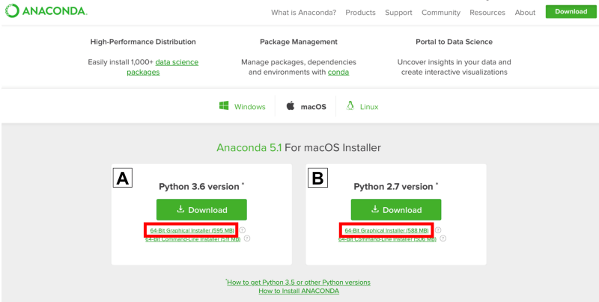

(2) Locate your downloaded file and double click it

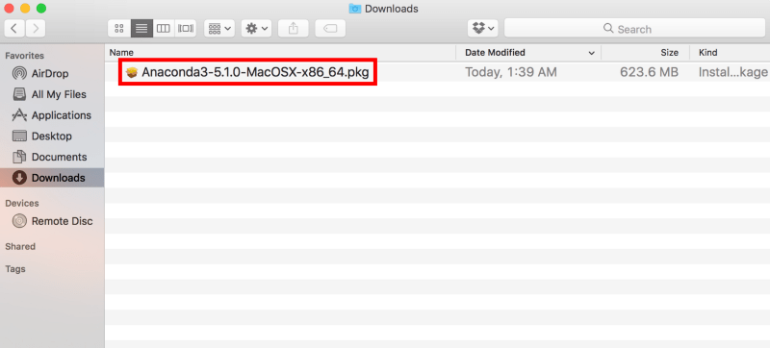

(3) Click on “*Continue*” and then following the instructions

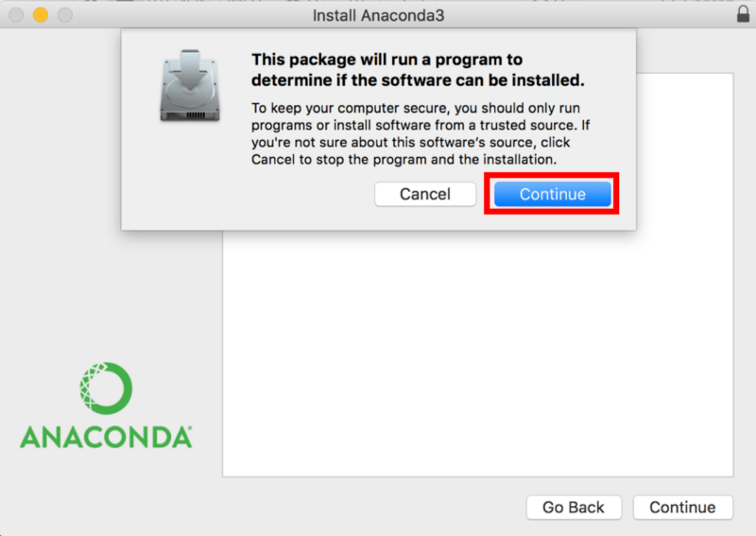

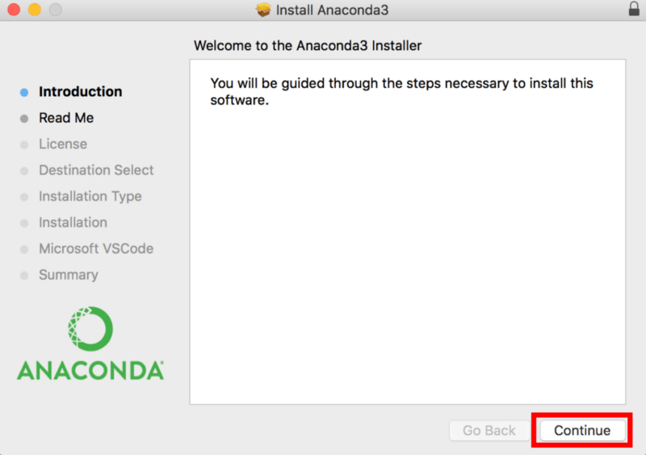

(4). Click on “*Install*”

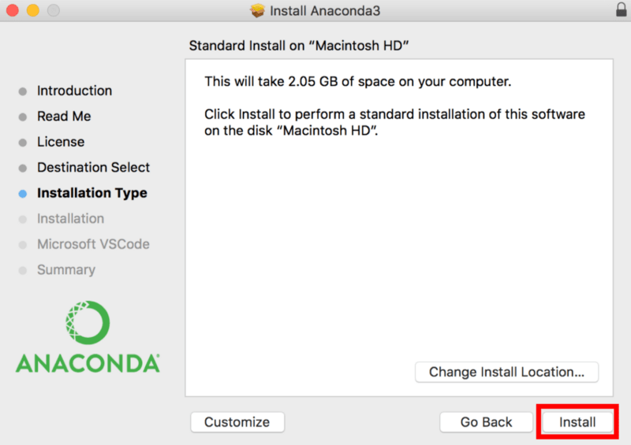

(5) Finally, click the “*close*” to finish the installment.

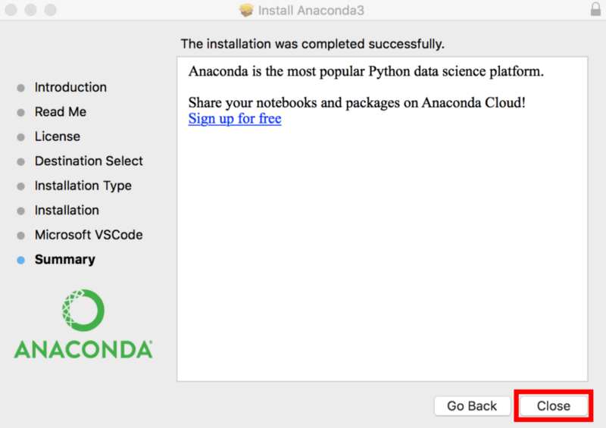

**For Windows**, reference: <https://problemsolvingwithpython.com/01-Orientation/01.03-Installing-Anaconda-on-Windows/>

Go to the website and then download the install file, <https://www.anaconda.com/download/>

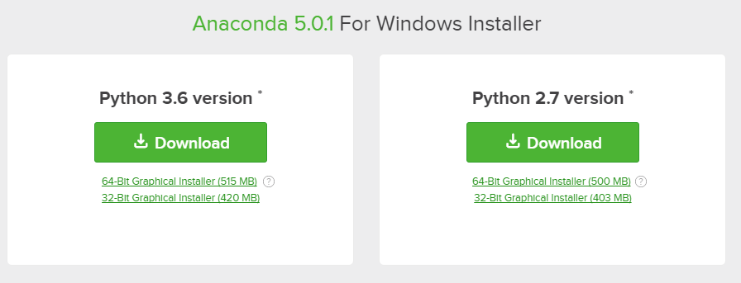

Locate the downloaded file and then install the file,

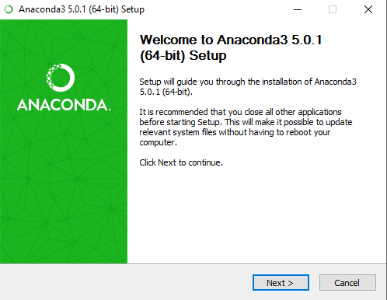

At the Advanced Installation Options screen, I recommend that you **do not check** "Add Anaconda to my PATH environment variable"

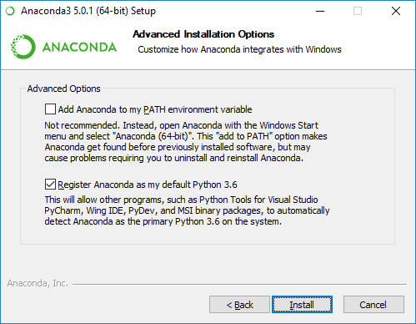

**2. Anaconda tutorial**

(1) Open the Anaconda command line terminal

For **Mac** users: Open your terminal directly. You may then see a window likes this.



For **Windows** users:

After the installation of Anaconda is complete, you can go to the Windows start menu and select the Anaconda Prompt.

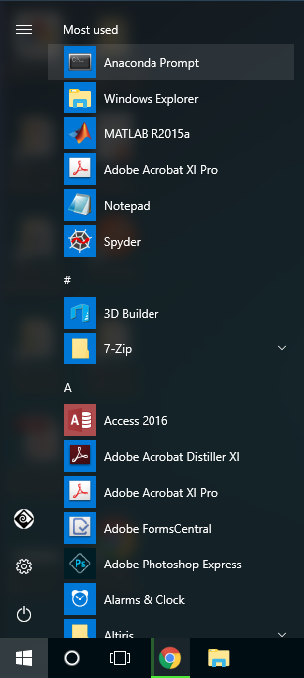

Windows look like this:

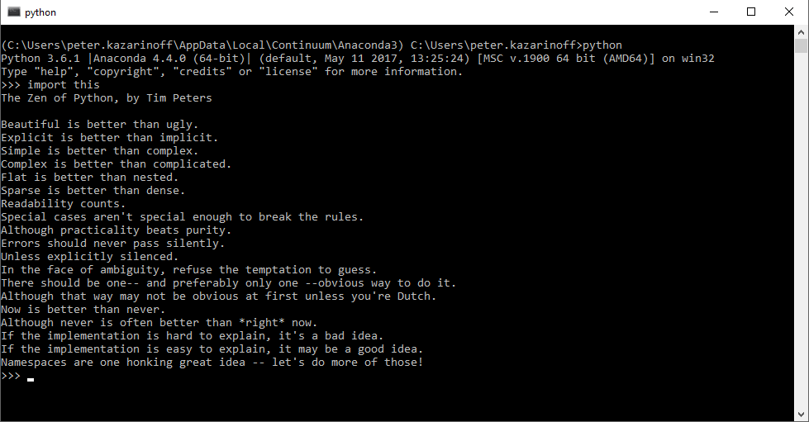

**Note**: *Anaconda is the Python distribution and the Anaconda Prompt is a command line shell (a program where you type in commands instead of using a mouse). The black screen and text that makes up the Anaconda Prompt doesn't look like much, but it is really helpful for problem solvers using Python.*

(2) Check the current conda virtual environment by typing,

conda info -e



If you have many virtual environments installed on your computer, then you will see a list of these. In this class, we can create a new virtual environment called “geoviz”. So, we can simply type,

conda create -n geoviz python=3.7

The above command will create a new virtual environment of “geoviz” with Python 3.7.



Type in “y” in the terminal, and then follow the instructions and you will have the virtual environment installed. If everything works, then you can type in

conda info -e

You should see the “geoviz” there. Then you have created the virtual environment of “geoviz” successfully.



Before we can use the created “geoviz” environment, we need to activate it first by,

conda activate geoviz

Then you can enter the virtual environment of geoviz



We are ready to go and write Python code! Let’s write a very simple Python code in the terminal. We can type in python in the terminal and then enter to the Python command line environment,



We can use the Python command line in the terminal now, let’s do simple calculation and print the python version by typing in,

Python 3.7.4 (default, Aug 13 2019, 15:17:50)

[Clang 4.0.1 (tags/RELEASE_401/final)] :: Anaconda, Inc. on darwin

Type "help", "copyright", "credits" or "license" for more information.

>>> print(2+4)

6

>>> import sys

>>> print(sys.version)

3.7.4 (default, Aug 13 2019, 15:17:50)

[Clang 4.0.1 (tags/RELEASE_401/final)]

>>>



(3) Install required modules using conda

After we get all the above setup, then we can use Anaconda to install Python modules. For example, in the lab we need to use the “Matplotlib” to plot graphics, then we can install the Matplotlib by simply typing,

conda install -c conda-forge matplotlib

We can also install other modules using conda easily. In the following labs, I will show you how to install different Python modules for different purposes.

**Reference**

Installing Anaconda on Mac OS X: <https://www.datacamp.com/community/tutorials/installing-anaconda-mac-os-x>

Install Anaconda on Mac, <https://docs.anaconda.com/anaconda/install/mac-os/>

Install Anaconda on Window, [https://docs.anaconda.com/anaconda/install/windows/#](https://docs.anaconda.com/anaconda/install/windows/)